Oobleck Experiment – Oobleck is a substance made from a mix of cornstarch and water. It can feel like a solid when you hold it into a ball but it becomes liquidy when you let your hand loose. Try this experiment, it is so much fun!

You need the follow materials

Corn starch – start with a cup , you can add more depending on how much you want

Water- start with ¼ cup and add gradually add as you like it

Food color of your choice- a few drops into the water

Bowl

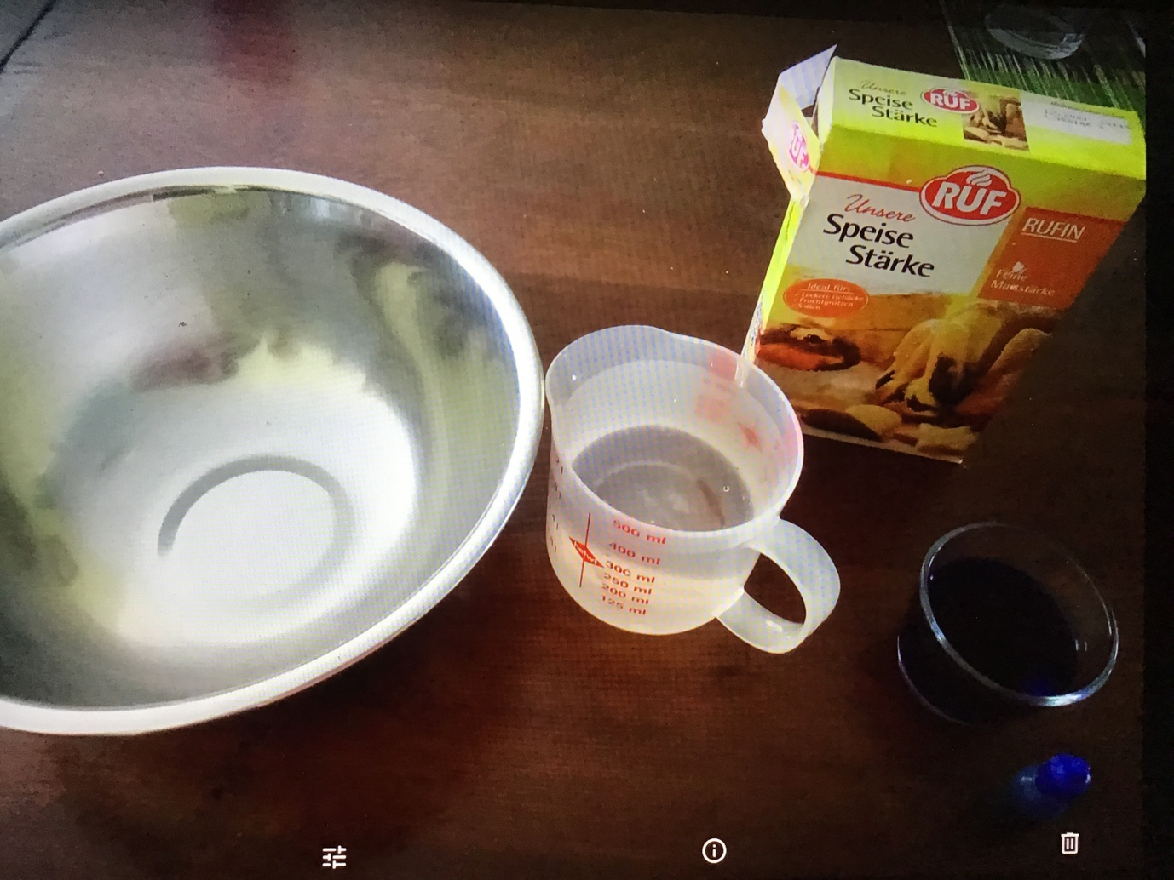

Mix them together

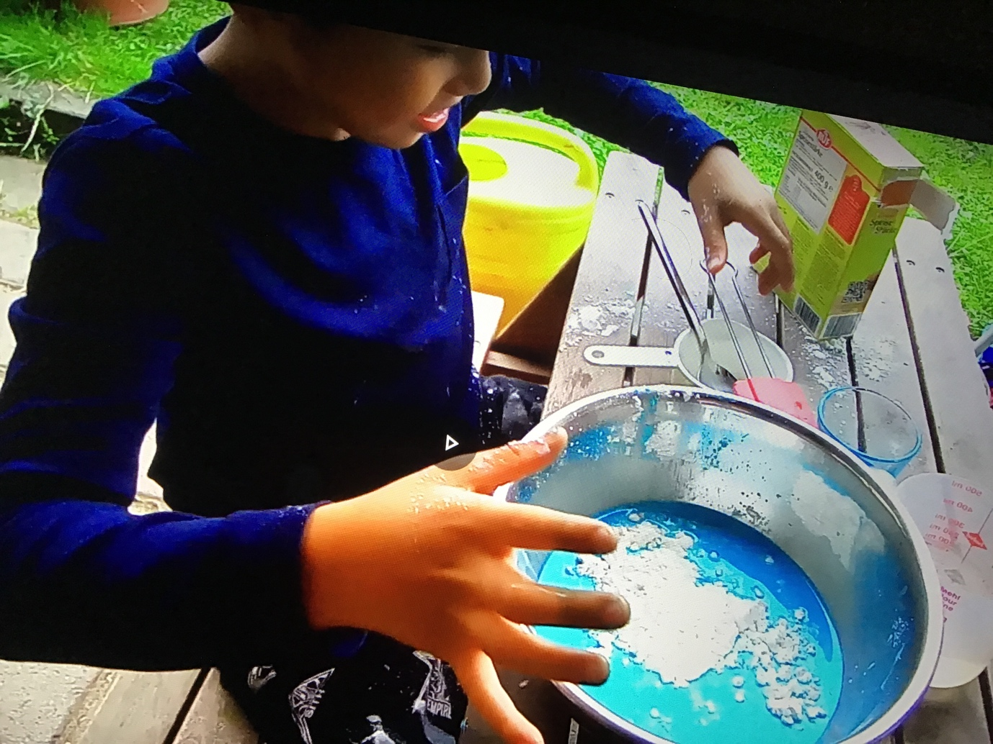

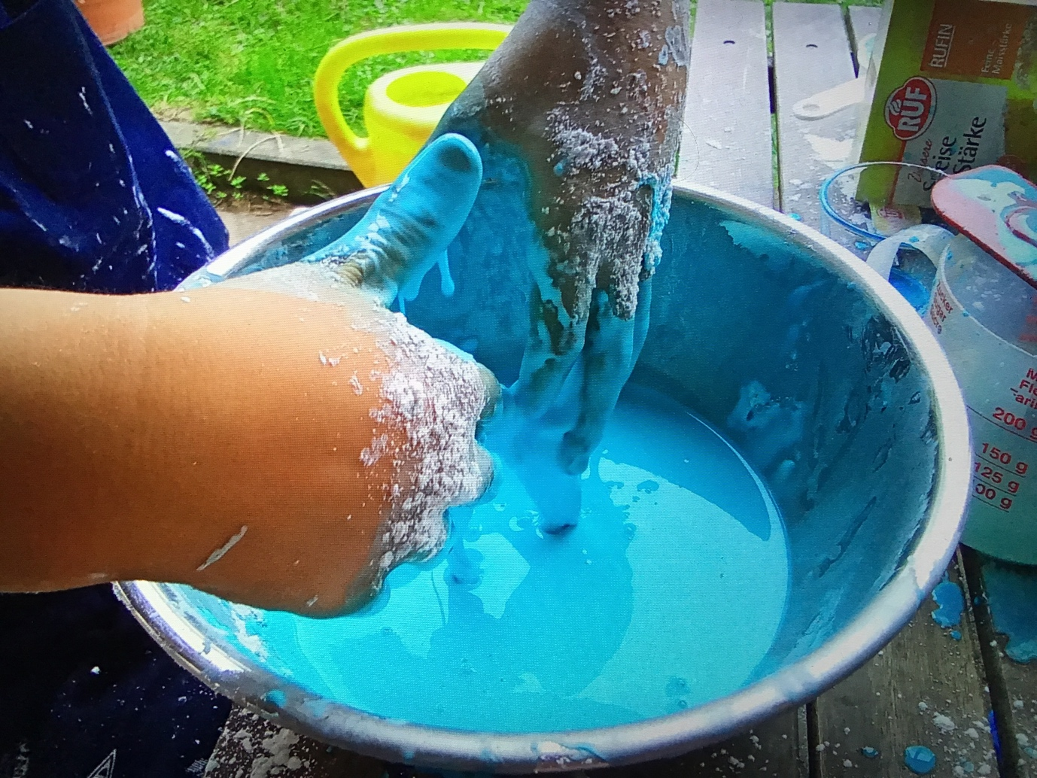 Have fun !

Have fun!

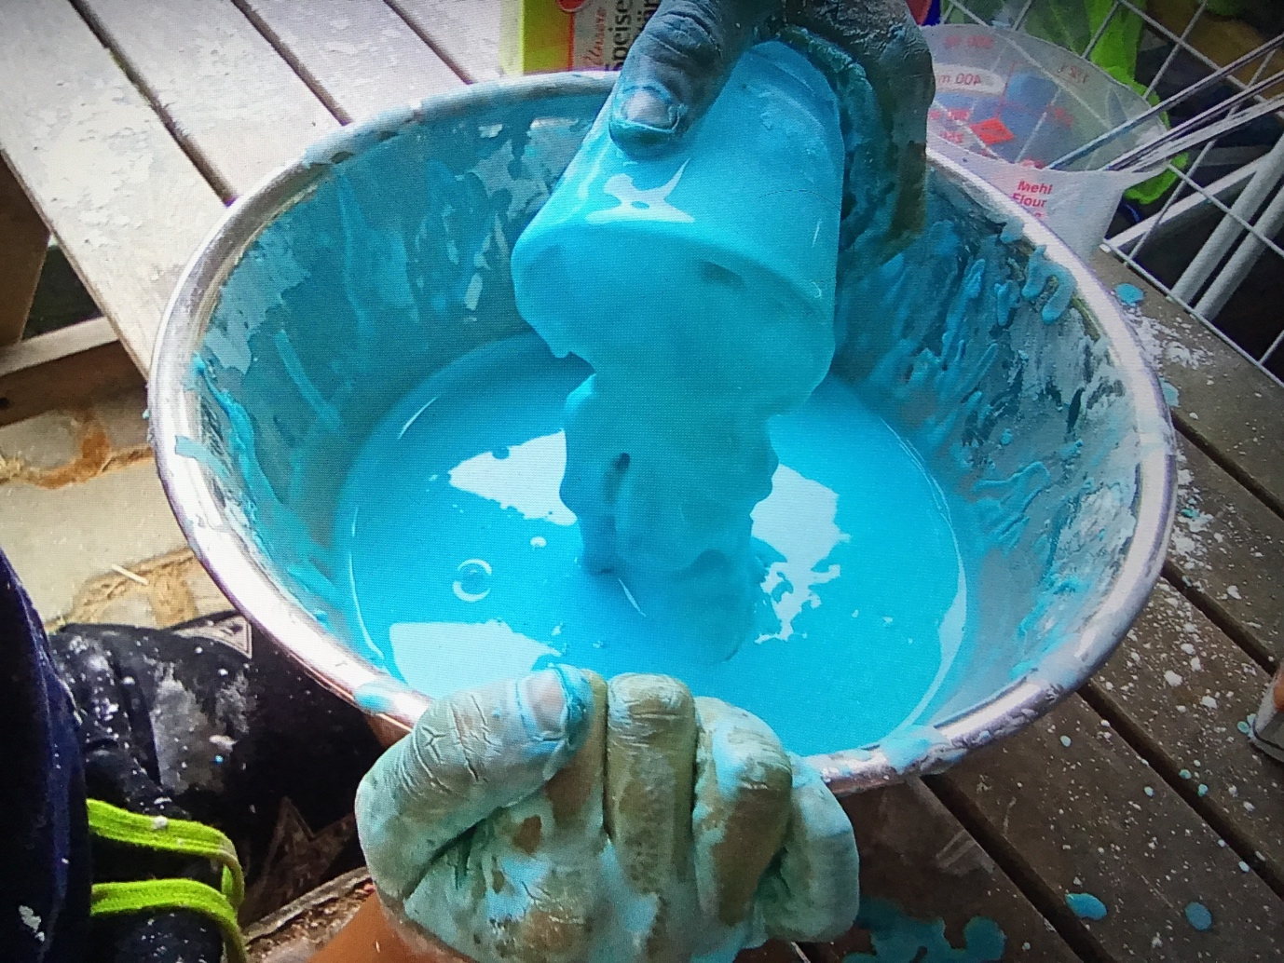

Make sure to throw your oobleck in the trash and not in the sink as this could cog the drainage! Wrap it in a plastic bag ad throw it in the bin.