***Cinnamon & Apple Cake***

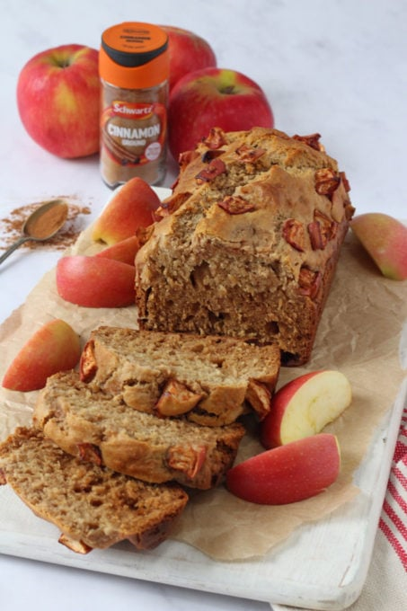

*A delicious apple cake flavoured with Schwartz Ground Cinnamon and sweetened only with fruit and honey*

*A delicious apple cake flavoured with Schwartz Ground Cinnamon and sweetened only with fruit and honey*

Ingredients

* 150g apple sauce
* 75g coconut oil or butter, melted
* 70g honey
* 60g plain yogurt
* 1 egg
* 275g plain flour
* 1 tsp baking powder
* 3/4 tsp baking soda
* 1/2 tsp Schwartz Ground Cinnamon

To top:

* 1 small apple, chopped
* 1 tsp brown sugar
* 1/2 tsp Schwartz Ground Cinnamon

Instructions

1. In a large jug mix together the apple sauce, melted coconut oil or butter, honey, yogurt and egg.
2. In a large bowl add the flour, baking powder, baking soda and cinnamon and mix.
3. Pour the wet ingredients into the dry ingredients and mix with a spoon just enough to combine everything.
4. Pour the mixture into a greased and line loaf tin.
5. In a small bowl toss together the chopped apples, sugar and cinnamon and sprinkle these over the top of the cake.
6. Bake in the oven at 180c for 30 minutes. Remove and cover the tin loosely with foil (this stops the top from over-browning) and return to the oven for another 20 minutes until cooked through.
7. Allow to cool a little before removing from the tin by lifting up the sides of the paper.
8. Allow to cool further on a wire rack before slicing and serving.

Easy Apple Pie for Kids

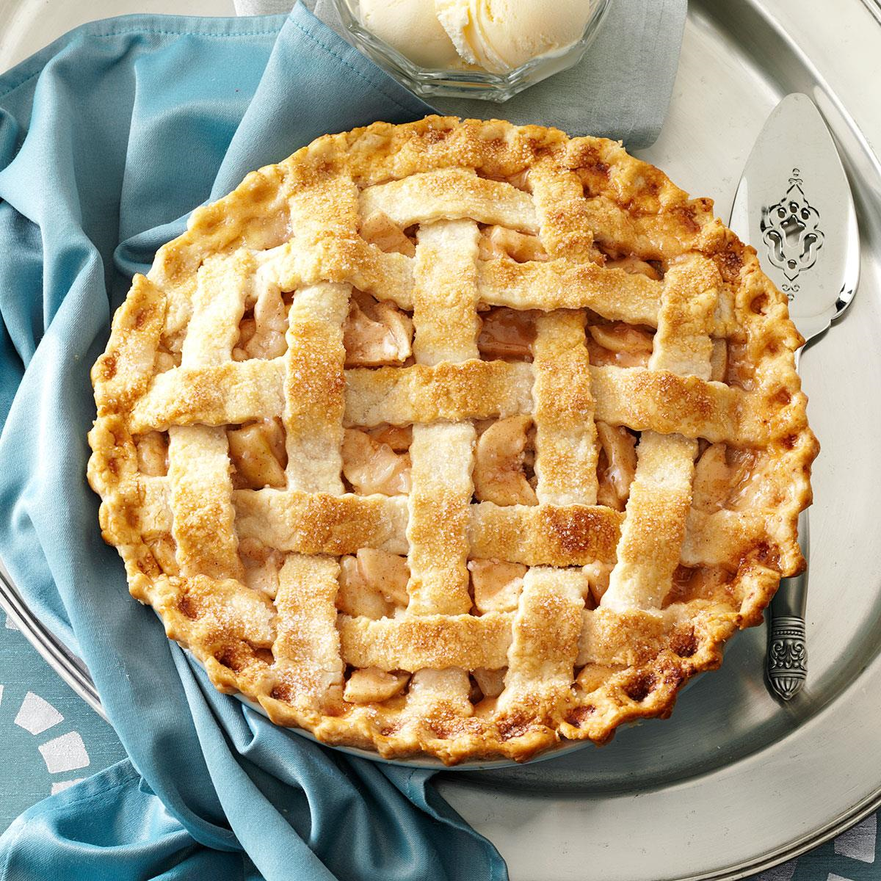

Ingredients

* 2 refrigerated pie crusts
* 1 [egg white](https://www.thespruceeats.com/how-to-separate-eggs-995520)
* 8 large [Golden Delicious](https://www.thespruceeats.com/apple-varieties-2216283) apples (peeled, cored, and sliced thinly)
* 1/3 cup granulated sugar
* 2 tablespoons all-purpose flour
* 1 teaspoon  [cinnamon](https://www.thespruceeats.com/history-of-cinnamon-1807584)

Steps to Make It

1. Gather the ingredients.
2. Preheat oven to 400 F.
3. Unfold one of the pie crusts onto a 9-inch pie plate. [Brush](https://www.amazon.com/OXO-Grips-Silicone-Basting-Pastry/dp/B000JPSI8C) with egg white (this prevents the crust from getting soggy). Let the egg white dry while you prepare the filling.
4. Toss apples with remaining ingredients. Place apples closely together into prepared crust.
5. Unfold the second prepared pie crust over the apples, tucking the excess under the bottom crust. Now [crimp](https://www.thespruceeats.com/how-to-crimp-pie-crust-4123830) the edges with your fingers.
6. [Cut 3 or 4 slits](https://www.thespruceeats.com/vents-in-pies-4158870) in the top crust to allow steam to escape. Brush the top of the crust with any remaining egg white (optional).
7. Cover the pie loosely with a sheet of aluminum foil.
8. Bake 10 minutes. Remove the foil, lower the temperature to 375 F, and bake another 30 to 40 minutes.
9. Once finished baking, set pie aside to cool.
10. Once cool, slice pie and serve with a glass of milk (or better yet, a scoop of [vanilla ice cream](https://www.thespruceeats.com/step-by-step-ice-cream-recipe-305349)!).